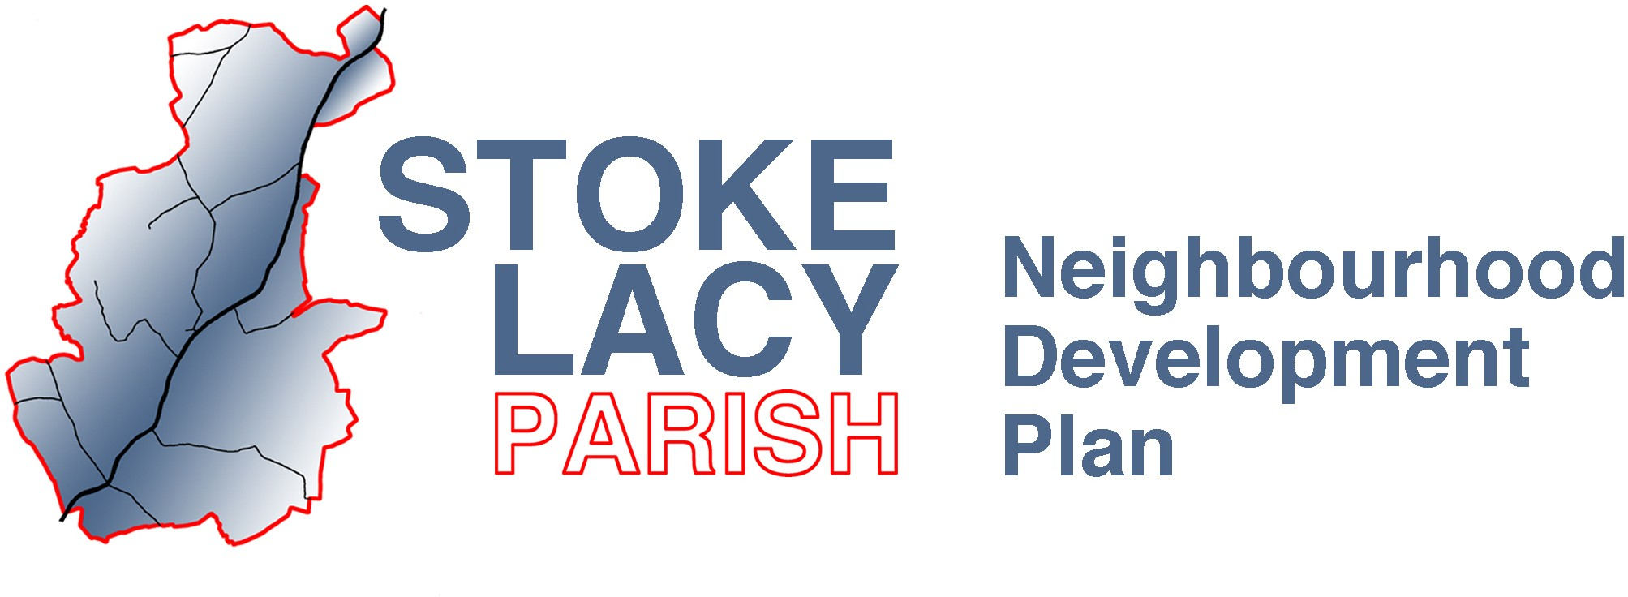

Stoke Lacy Neighbourhood Development Plan Steering Group Meeting 24th November 2022 at 7pm in the Plough Inn

Attendees: Jo Davies, James Wilson, Bill Morgan, Emma, John Davies, Freddie Lewis, Charlotte Lewis, Ali Parker
Optional: Janet Ivison, Anne Reece
Agenda:
- Agree notes from last meeting
- Agree design for Banners
- Locations for Banners / other publicity
- Content for reminder handout
- Distribution dates
- AOB

Draft plan:
- Dec 5th – Design and agree layout for banners (larger than last time)
- Dec 5th – Design handout (brief history, reasons why it’s important, date, time and venue)
- Dec 27th – Put up Banners after Christmas (2 weeks before referendum)
- Jan 4th – Distribute reminder handout (first week in January)
- Jan 11th – Parish Council Meeting
- Jan 12th – Provisional date for referendum

